Document Title | Behaviour Policy
Review Frequency | Annually
Last Full Review | November 2025
Next Full Review Date | November 2026
Policy Author | Miss E Waspe – Deputy Headteacher

Misson statement:
Our vision is to deliver a high-quality, bespoke education within a supportive, reflective, and purposeful learning environment. We are committed to consistently meeting the unique needs of our students and their families, ensuring they feel safe, valued, and empowered to grow. Through a therapeutic approach, we aim to inspire better life choices and create clear pathways to a happy, successful future.
Our Values:
Respect | Responsibility | Resilience

Respect - At EAP staff and students show respect for themselves and their community.
Responsibility - At EAP staff and students take responsibility for their own choices and actions. We admit our mistakes, accept the consequences, and learn to grow.
Resilience - At EAP staff and students have high expectations, rise to any challenge, learn from their mistakes and have the courage to admit when we are wrong.
We believe that diversity is the cornerstone of our community. We are committed to creating an inclusive environment that celebrates the unique backgrounds, experiences, perspectives of all our students and staff. We recognise that diversity enriches our learning and strengthens our community, and we strive to foster a culture of respect, empathy, and understanding. We are dedicated to providing a safe and welcoming space where everyone feels valued and supported, where we can all learn from each other. Together, we are building a community that embraces diversity and promotes equity and inclusion.

Aims of this Policy
The purpose of this Behaviour Policy is to:
- Promote positive behaviour choices and relationships across the school.
- Ensure a consistent, fair, and restorative approach to managing behaviour.
- Support students to understand and regulate their emotions.
- Maintain a safe, nurturing, and inclusive environment for all.
- Build resilience, responsibility, and respect through reflection and restorative practice.
We adopt a trauma-informed, relational approach, recognising that all behaviour is a form of communication and that positive relationships are key to lasting change.

Understanding Our Students
Students at EAP often join us with diverse and complex experiences that may include trauma, disrupted education, or unmet needs.
We respond by:
- Building strong, trusting relationships.
- Creating predictable routines and safe spaces.
- Offering flexible, personalised provision.
- Planning engaging, purposeful learning experiences.
- Using a trauma-informed and restorative approach to behaviour.
We believe every student can learn and change when provided with the right environment and support.

Expectations of Students
Alongside our values, we expect all students to:
- Show respect to staff, peers, and themselves.
- Engage positively with learning.
- Follow instructions from staff.
- Maintain the safety and wellbeing of the community.
- Not buy or sell any items to other students.
Buying and selling creates unsafe situations, can lead to conflict, pressure, or exploitation, and is strictly prohibited on and around the school site.

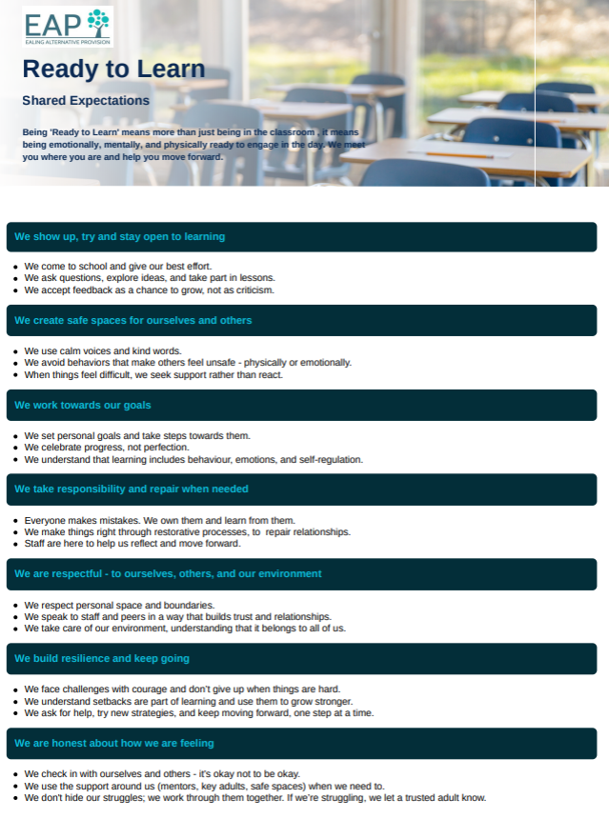

EAP Three-Tier Behaviour Support System
Our three-tiered system provides clear, consistent guidance for responding to behavioural incidents while maintaining a therapeutic, restorative ethos.
Overview
Tier | Description | Response Level
Tier 1 | Minor detrimental behaviours | Classroom-based intervention
Tier 2 | Moderate detrimental behaviours | Restorative intervention and Reset Room support
Tier 3 | Serious incidents / detrimental dangerous behaviours | Senior leadership involvement and formal response

This framework ensures that staff respond proportionately and consistently, always prioritising safety, dignity, and opportunities for repair.
Tier 1: Minor Detrimental Behaviours
These are low-level behaviours that can typically be managed by the classroom teacher.
The goal is to minimise disruption, redirect learning, and support self-regulation.
Intervention focus: Timely, low-level intervention prevents escalation and models emotional regulation.
Tier 2: Moderate Detrimental Behaviours
These behaviours require immediate, supportive intervention. The emphasis remains on understanding the underlying cause, maintaining safety, and repairing relationships.
Examples include:
- Persistent disruption despite reminders.
- Offensive or inappropriate language.
- Damaging property.
- Repeated refusal to follow reasonable instructions.
- Inappropriate physical contact or play fighting.

Intervention focus: Restoring relationships, reinforcing safety, and promoting reflection.
Tier 3: Serious Incidents – Detrimental Dangerous Behaviour
These are serious breaches of EAP’s code of conduct that pose a risk to the safety or wellbeing of others. They require immediate senior leadership intervention and may result in formal consequences, in line with statutory guidance.
Examples include:
- Physical violence or aggression.
- Threats or serious verbal abuse towards staff or peers.
- Racist, sexist, or homophobic language.
- Possession of drugs, alcohol, or weapons.
- Deliberate damage or theft.
- Refusal to surrender mobile phone.
- False activation of alarms.
Possible Outcomes:
- Restorative justice or community service.
- Internal “Reset Day” or change of provision
- Suspension
Restorative Approach
When behaviour causes harm, we support students to:
- Reflect on what happened.
- Understand the impact of their actions.
- Take responsibility and make amends.
- Restore relationships and rebuild trust.

Uniform
*please see uniform policy
Students are expected to wear the following uniform:
Polo shirt | white polo shirt – no patterns, logos, or branding
Sweatshirt | black round neck sweatshirt – no logos, branding, or patterns
Trousers | black loose-fitting school trousers
Skirt | knee-length black school skirt
Footwear | Plain black school shoes or plain black trainers – no visible logos, colours, or branding
Socks/tights | Plain black socks

Please be aware that students who arrive onsite in incorrect uniform will remain in our pastoral office until a parent or carer has been contacted. In most circumstances, we will require the correct uniform to be brought into school.
If there is a valid reason why your child is unable to attend in the correct uniform on a particular day, please ensure you notify the school in advance so we are aware of the situation.

Additionally, please note that persistent breaches of the uniform policy may result in a Reset Day being issued. During a Reset Day, your child may be kept away from the main school community so that expectations can be revisited and standards re-established

Suspensions
Most pupils have experienced suspensions and/or exclusions and the emotional damage caused by it. Where possible, EAP will use alternatives to fixed term suspension, for example, supported working 1:1 with a member of staff until the school feels it is safe for the pupil to return to the classroom environment. The Headteacher also reserves the right to change a pupil’s provision to off-site, if it is deemed appropriate.
It is understood by all stakeholders that suspensions will be used as a last resort and in serious circumstances where a clear message is being given that for a temporary period of time, the pupil is unsafe to be part of the school community, as their choices and actions have been harmful and hurtful.

Searching, Screening and Confiscation
Pupils are screened on their arrival to school.
The list of prohibited items are:
- knives and weapons;
- alcohol;
- illegal drugs;
- stolen items;
- any article that the member of staff reasonably suspects has been, or is likely to be used:
  - to commit an offence,
  - to cause personal injury to,
  - damage to property of; any person (including the pupil).
- tobacco, cigarette papers and electrical smoking devices
- fireworks
- pornographic images.

